**LAB 8**

Aim: To implement Mutual Exclusion / Deadlock Detection

Lab Outcome:

Demonstrate Mutual Exclusion algorithms and deadlock handling

Theory:

Mutual Exclusion in Distributed System:

Mutual exclusion is a concurrency control property which is introduced to prevent race

conditions. It is the requirement that a process cannot enter its critical section while

another concurrent process is currently present or executing in its critical section i.e., only

one process is allowed to execute the critical section at any given instance of time.

In Distributed systems, we neither have shared memory nor a common physical clock and

Therefore we cannot solve the mutual exclusion problem using shared variables. To eliminate

the mutual exclusion problem in distributed system approach based on message passing is

used.

Requirements of Mutual exclusion Algorithm:

• No Deadlock:

Two or more site should not endlessly wait for any message that will never arrive.

• No Starvation:

Any site should not wait indefinitely to execute critical section while other sites are

repeatedly executing critical section

• Fairness:

Each site should get a fair chance to execute critical section. Any request to execute

critical section must be executed in the order they are made.

• Fault Tolerance:

In case of failure, it should be able to recognize it by itself in order to continue

functioning without any disruption.

Solution to distributed mutual exclusion:

As we know shared variables or a local kernel cannot be used to implement mutual

exclusion in distributed systems. Message passing is a way to implement mutual exclusion.

Below are the three approaches based on message passing to implement mutual exclusion

in distributed systems:

Token Based Algorithm:

• A unique token is shared among all the sites.

• If a site possesses the unique token, it is allowed to enter its critical section

• This approach uses sequence number to order requests for the critical section.

• Each requests for critical section contains a sequence number. This sequence

number is used to distinguish old and current requests.

• This approach insures Mutual exclusion as the token is unique

• Example: Suzuki-Kasami’s Broadcast Algorithm

Non-token based approach:

• A site communicates with other sites in order to determine which sites should

execute critical section next. This requires exchange of two or more successive round

of messages among sites.

• This approach use timestamps instead of sequence number to order requests for the

critical section.

• When ever a site make request for critical section, it gets a timestamp. Timestamp is

also used to resolve any conflict between critical section requests.

• All algorithm which follows non-token based approach maintains a logical clock.

Logical clocks get updated according to Lamport’s scheme

• Example: Lamport's algorithm, Ricart–Agrawala algorithm

Quorum based approach:

• Instead of requesting permission to execute the critical section from all other sites,

Each site requests only a subset of sites which is called a quorum.

• Any two subsets of sites or Quorum contains a common site.

• This common site is responsible to ensure mutual exclusion

• Example: Maekawa’s Algorithm

Deadlock Handling:

The following are the strategies used for Deadlock Handling in Distributed System:

1. Deadlock Prevention: As the name implies, this strategy ensures that deadlock can never

happen because system designing is carried out in such a way. If any one of the deadlock-

causing conditions is not met then deadlock can be prevented. Following are the three

methods used for preventing deadlocks by making one of the deadlock conditions to be

unsatisfied:

Collective Requests: In this strategy, all the processes will declare the required

resources for their execution beforehand and will be allowed to execute only if there

is the availability of all the required resources. When the process ends up with

processing then only resources will be released. Hence, the hold and wait condition

of deadlock will be prevented.

But the issue is initial resource requirements of a process before it starts are based

on an assumption and not because they will be required. So, resources will be

unnecessarily occupied by a process and prior allocation of resources also affects

potential concurrency.

Ordered Requests: In this strategy, ordering is imposed on the resources and thus,

process requests for resources in increasing order. Hence, the circular wait condition

of deadlock can be prevented.

An ordering strictly indicates that a process never asks for a low resource while

holding a high one.

There are two more ways of dealing with global timing and transactions in

distributed systems, both of which are based on the principle of assigning a global

timestamp to each transaction as soon as it begins.

It is better to give priority to the old processes because of their long existence and

might be holding more resources.

It also eliminates starvation issues as the younger transaction will eventually be out

of the system.

Pre-emption: Resource allocation strategies that reject no-pre-emption conditions

can be used to avoid deadlocks.

Wait-die: If an older process requires a resource held by a younger process, the

latter will have to wait. A young process will be destroyed if it requests a resource

controlled by an older process.

Wound-wait: If an old process seeks a resource held by a young process, the young

process will be pre-empted, wounded, and killed, and the old process will resume

and wait. If a young process needs a resource held by an older process, it will have to

wait.

2. Deadlock Avoidance: In this strategy, deadlock can be avoided by examining the state of

the system at every step. The distributed system reviews the allocation of resources and

wherever it finds an unsafe state, the system backtracks one step and again comes to the

safe state. For this, resource allocation takes time whenever requested by a process. Firstly,

the system analysis occurs whether the granting of resources will make the system in a safe

state or unsafe state then only allocation will be made.

A safe state refers to the state when the system is not in deadlocked state and order is there

for the process regarding the granting of requests.

An unsafe state refers to the state when no safe sequence exists for the system. Safe

sequence implies the ordering of a process in such a way that all the processes run to

completion in a safe state.

3. Deadlock Detection and Recovery: In this strategy, deadlock is detected and an attempt

is made to resolve the deadlock state of the system. These approaches rely on a Wait-For-

Graph (WFG), which is generated and evaluated for cycles in some methods.

The following two requirements must be met by a deadlock detection algorithm:

Progress: In a given period, the algorithm must find all existing deadlocks. There

should be no deadlock existing in the system which is undetected under this

condition. To put it another way, after all, wait-for dependencies for a deadlock have

arisen, the algorithm should not wait for any additional events to detect the

deadlock.

No False Deadlocks: Deadlocks that do not exist should not be reported by the

algorithm which is called phantom or false deadlocks.

There are different types of deadlock detection techniques:

Centralized Deadlock Detector: The resource graph for the entire system is managed

by a central coordinator. When the coordinator detects a cycle, it terminates one of

the processes involved in the cycle to break the deadlock. Messages must be passed

when updating the coordinator’s graph. Following are the methods:

A message must be provided to the coordinator whenever an arc is created or

removed from the resource graph.

Hierarchical Deadlock Detector: In this approach, deadlock detectors are arranged in

a hierarchy. Here, only those deadlocks can be detected that fall within their range.

Distributed Deadlock Detector: In this approach, detectors are distributed so that all

the sites can fully participate to resolve the deadlock state. In one of the following

below four classes for the Distributed Detection Algorithm- The probe-based scheme

can be used for this purpose. It follows local WFGs to detect local deadlocks and

probe messages to detect global deadlocks.

There are four classes for the Distributed Detection Algorithm:

• Path-pushing: In path-pushing algorithms, the detection of distributed deadlocks is

carried out by maintaining an explicit global WFG.

• Edge-chasing: In an edge-chasing algorithm, probe messages are used to detect the

presence of a cycle in a distributed graph structure along the edges of the graph.

• Diffusion computation: Here, the computation for deadlock detection is dispersed

throughout the system’s WFG.

• Global state detection: The detection of Distributed deadlocks can be made by taking

a snapshot of the system and then inspecting it for signs of a deadlock.

Implementation:

Suzuki-Kasami Algorithm:

1. To enter Critical section:

• When a site Si wants to enter the critical section and it does not have the

token then it increments its sequence number RNi[i] and sends a request

message REQUEST(i, sn) to all other sites in order to request the token.

Here sn is update value of RNi[i]

• When a site Sj receives the request message REQUEST(i, sn) from site Si, it

sets RNj[i] to maximum of RNj[i] and sn i.e RNj[i] = max(RNj[i], sn).

• After updating RNj[i], Site Sj sends the token to site Si if it has token

and RNj[i] = LN[i] + 1

2. To execute the critical section:

• Site Si executes the critical section if it has acquired the token.

3. To release the critical section:

After finishing the execution Site Si exits the critical section and does following:

• sets LN[i] = RNi[i] to indicate that its critical section request RNi[i] has been

executed

• For every site Sj, whose ID is not present in the token queue Q, it appends

its ID to Q if RNi[j] = LN[j] + 1 to indicate that site Sj has an outstanding

request.

• After above updation, if the Queue Q is non-empty, it pops a site ID from

the Q and sends the token to site indicated by popped ID.

• If the queue Q is empty, it keeps the token

Message Complexity:

The algorithm requires 0 message invocation if the site already holds the idle token at the

time of critical section request or maximum of N message per critical section execution.

This N messages involves

• (N – 1) request messages

• 1 reply message

Code:

import keyboard

import time

import threading

runningP = -1

# RN arrays of processes

RN = {

0: [0, 0, 0, 0, 0],

1: [0, 0, 0, 0, 0],

2: [0, 0, 0, 0, 0],

3: [0, 0, 0, 0, 0],

4: [0, 0, 0, 0, 0]

}

token = {

"token_owner": 2,

"Q": [],

"LN": [0, 0, 0, 0, 0],

"isRunning": False

}

def dispCurrentRNState():

for key, value in RN.items():

print(key, ": ", value)

def updateRN(processNo, sequenceNumber):

for key, value in RN.items():

value[processNo] = max(value[processNo], sequenceNumber)

# Execute cs and remaining tasks

def executeCS(processForCS):

print("\n\n")

print(f"Process {processForCS} executing CS...")

print('Token owner is: {}'.format(token["token_owner"]))

time.sleep(10)

print(f'\nProcess {processForCS} has completed running CS')

# Process completed CS

token["isRunning"] = False

#update LN

token["LN"][processForCS] = RN[processForCS][processForCS]

# print(f"Process Completed CS")

#Check For Outstanding Requests

# For every site Sj, whose ID is not present in the token queue Q, it appends its ID to Q if RNi[j] = LN[j] + 1 to indicate that site Sj has an outstanding request.

for index, val in enumerate(RN[token["token_owner"]]):

# print("Running P: ", runningP)

if(val == token["LN"][index] + 1 and index != runningP and index not in token["Q"]):

# outstanding Requests

print(f'Process {index}\'s request is outstanding, it will be added to Token\'s Queue')

token["Q"].append(index)

print(f'Queue: {token["Q"]}')

#Handing out the token

if(len(token["Q"]) != 0):

# pop a process from the queue and give it the token

poppedPs = token["Q"].pop(0)

token["token_owner"] = poppedPs

token["isRunning"] = True

executeCS(poppedPs)

# def main():

if __name__ == "__main__":

# print("Press Key E to exit")

print("Running Main Again")

# Display Current State of RN Arrays

print("Current RN Arrays: ")

dispCurrentRNState()

print(" ")

print('Token owner is: {}'.format(token["token_owner"]))

while True:

if(token["isRunning"]):

processes = input(

"Enter Process Numbers which want to access C.S separated by space (Click N for None): ")

if(processes != 'N'):

psList = processes.strip().split(" ")

print(" ")

for ps in psList:

processForCS = int(ps)

print(f"* Process {processForCS} *")

seqNo = RN[processForCS][processForCS]+1

# Broadcasting Request

print(f"Process No.: {processForCS}")

print(f"Sequence No.: {seqNo}")

print(f"Broadcasting Request ({processForCS} , {seqNo}) .......")

time.sleep(2)

print("Broadcast complete")

print(" ")

# Updating RN Arrays

print("Updating RN Arrays at all process sites")

updateRN(processForCS, seqNo)

print("Current RN Arrays: ")

dispCurrentRNState()

print(" ")

else:

processForCS = int(input("Enter Process No. which wants to access C.S: "))

seqNo = RN[processForCS][processForCS]+1

# Broadcasting Request

print(f"Process No.: {processForCS}")

print(f"Sequence No.: {seqNo}")

print(f"Broadcasting Request ({processForCS} , {seqNo}) .......")

time.sleep(2)

print("Broadcast complete")

print(" ")

# Updating RN Arrays

print("Updating RN Arrays at all process sites")

updateRN(processForCS, seqNo)

print("Current RN Arrays: ")

dispCurrentRNState()

print(" ")

# Check condition of sending token: RNj[i] = LN[i] + 1

if(RN[token["token_owner"]][processForCS] == token["LN"][processForCS] + 1):

# give the token

print(f"Conditions met, giving token to {processForCS}...")

token["token_owner"] = processForCS

# print(f"New Token Owner: {token["token_owner"]}")

print('Token owner is: {}'.format(token["token_owner"]))

token["isRunning"] = True

runningP = processForCS

thread = threading.Thread(target=executeCS, args=(processForCS, ))

thread.start()

print("Main Continuing Running")

if keyboard.is_pressed('E'):

break

# main()

Output:

unning Main Again

Current RN Arrays:

0 : [0, 1, 0, 0, 0]

1 : [0, 1, 0, 0, 0]

2 : [0, 1, 0, 0, 0]

3 : [0, 1, 0, 0, 0]

4 : [0, 1, 0, 0, 0]

Token owner is: 1

Enter Process No. which wants to access C.S: 1

Process No.: 1

Sequence No.: 2

Broadcasting Request (1 , 2) .......

Broadcast complete

Updating RN Arrays at all process sites

Current RN Arrays:

0 : [0, 2, 0, 0, 0]

1 : [0, 2, 0, 0, 0]

2 : [0, 2, 0, 0, 0]

3 : [0, 2, 0, 0, 0]

4 : [0, 2, 0, 0, 0]

Conditions met, giving token to 1...

Token owner is: 1

Main Continuing Running

Process 1 executing CS...

Token owner is: 1

Enter Process Numbers which want to access C.S separated by space (Click N for None): N

Enter Process Numbers which want to access C.S separated by space (Click N for None): 2

* Process 2 *

Process No.: 2

Sequence No.: 1

Broadcasting Request (2 , 1) .......

Broadcast complete

Updating RN Arrays at all process sites

Current RN Arrays:

0 : [0, 2, 1, 0, 0]

1 : [0, 2, 1, 0, 0]

2 : [0, 2, 1, 0, 0]

3 : [0, 2, 1, 0, 0]

4 : [0, 2, 1, 0, 0]

Process 1 has completed running CS

Process 2's request is outstanding, it will be added to Token's Queue

Queue: [2]

Process 2 executing CS...

Token owner is: 2

Enter Process Numbers which want to access C.S separated by space (Click N for None): 4

* Process 4 *

Process No.: 4

Sequence No.: 1

Broadcasting Request (4 , 1) .......

Broadcast complete

Updating RN Arrays at all process sites

Current RN Arrays:

0 : [0, 2, 1, 0, 1]

1 : [0, 2, 1, 0, 1]

2 : [0, 2, 1, 0, 1]

3 : [0, 2, 1, 0, 1]

4 : [0, 2, 1, 0, 1]

Enter Process Numbers which want to access C.S separated by space (Click N for None): 3

Process 2 has completed running CS

Process 4's request is outstanding, it will be added to Token's Queue

Queue: [4]

Process 4 executing CS...

Token owner is: 4

* Process 3 *

Process No.: 3

Sequence No.: 1

Broadcasting Request (3 , 1) .......

Broadcast complete

Updating RN Arrays at all process sites

Current RN Arrays:

0 : [0, 2, 1, 1, 1]

1 : [0, 2, 1, 1, 1]

2 : [0, 2, 1, 1, 1]

3 : [0, 2, 1, 1, 1]

4 : [0, 2, 1, 1, 1]

Enter Process Numbers which want to access C.S separated by space (Click N for None): nhujn

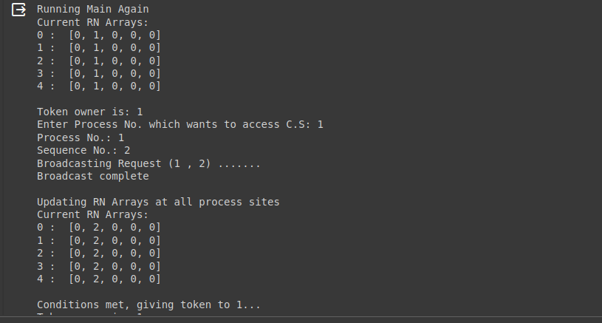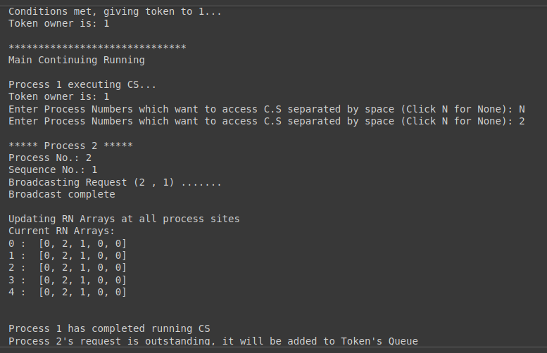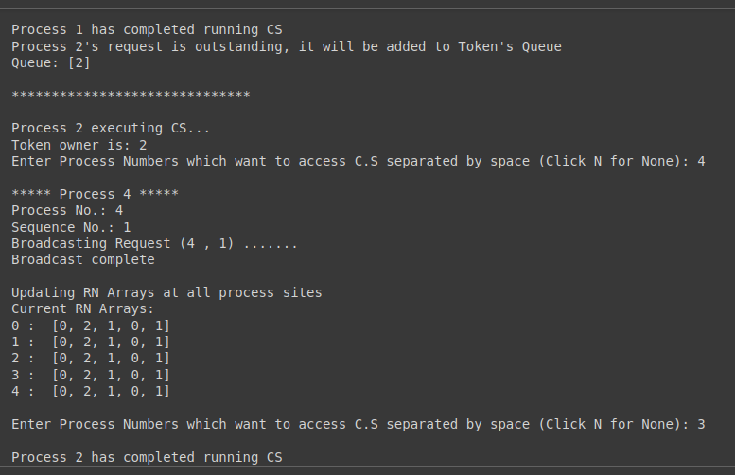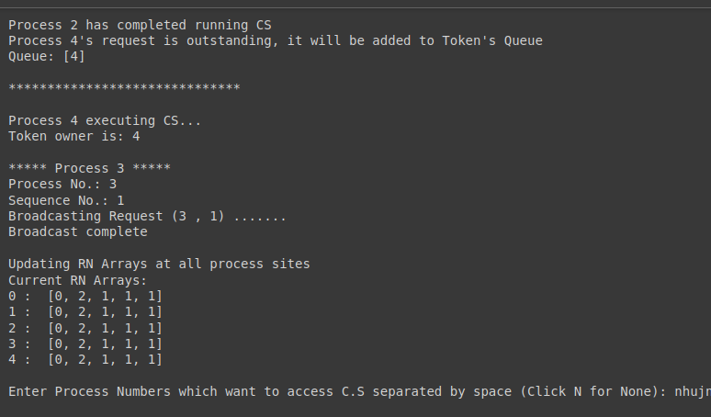

Conclusion:

In conclusion, our experiment focused on studying mutual exclusion and deadlock handling

in a distributed system. We implemented a simulation of the Suzuki-Kasami algorithm as a

solution to the challenges we identified. The algorithm demonstrated how processes in a

distributed system can coordinate with each other to prevent race conditions and ensure

mutual exclusion, without causing deadlocks.

Postlab Questions:

1. Explain the different ways of recovery from deadlock.

Deadlock is a state in a system where two or more processes are unable to proceed because each is waiting for the other to release resources. Recovering from a deadlock involves resolving the situation so that the processes can continue execution. Here are some common ways to recover from deadlock:

1. Detection and Recovery: Detecting deadlock involves periodically checking the system state to see if deadlock has occurred. Once deadlock is detected, recovery mechanisms are initiated to break the deadlock. Recovery strategies may involve killing processes, preempting resources, or rolling back transactions to release the resources held by processes involved in the deadlock.

2. Resource Preemption: In resource preemption, the system identifies a process involved in the deadlock and forcibly removes resources from it, thereby breaking the deadlock. The removed resources are then allocated to other processes that need them. However, care must be taken to ensure that preemption is done in a way that does not lead to starvation or unfairness.

3. Process Termination: Another approach is to terminate one or more processes involved in the deadlock. The terminated processes release the resources they hold, allowing other processes to proceed. However, care must be taken to choose which processes to terminate to minimize disruption and avoid data loss or corruption.

4. Resource Allocation/Deallocation: In some cases, it may be possible to prevent deadlock by carefully managing how resources are allocated and deallocated. Techniques such as resource ordering, where processes are required to request resources in a predefined order, can help prevent circular waits and thus avoid deadlock.

5. Timeouts and Rollback: Timeouts can be set on resource requests, and if a process waits for a resource for too long, it can be assumed to be deadlocked and recovery mechanisms can be initiated. Rollback mechanisms may be employed to undo the effects of operations performed by processes involved in the deadlock, allowing them to restart from a known state.

6. Avoidance: Deadlock avoidance techniques involve dynamically analyzing the resource allocation state to ensure that the system remains in a safe state, where deadlock cannot occur. Techniques such as Banker's algorithm use resource allocation strategies that ensure that processes can always acquire the resources they need without leading to deadlock.

2. What are the features of CMH algorithm

The CMH (Coffman-Meggs-Hoare) deadlock detection algorithm is a graph-based approach used to detect deadlocks in resource allocation systems. It was proposed by Edward G. Coffman Jr., A. M. Law, and C. A. R. Hoare. The algorithm operates by constructing a wait-for graph and then detecting cycles within this graph, which represent deadlocks. Here are the main features of the CMH deadlock detection algorithm:

1. 0Wait-for Graph Construction: The CMH algorithm constructs a wait-for graph based on the current state of the system. In this graph, nodes represent processes, and edges represent resource dependencies. Specifically, an edge from process \( P_i \) to process \( P_j \) indicates that \( P_i \) is waiting for a resource currently held by \( P_j \).

2. Cycle Detection: After constructing the wait-for graph, the CMH algorithm checks for cycles within the graph. A cycle in the wait-for graph indicates the presence of a potential deadlock. If a cycle is found, deadlock is suspected, and further analysis is needed to confirm it.

3. Resource Allocation and Deallocation Tracking: The algorithm keeps track of resource allocations and deallocations in the system to maintain an up-to-date wait-for graph. Whenever a process requests a resource, or when a resource is released by a process, the wait-for graph is updated accordingly.

4. Deadlock Detection: By analyzing the wait-for graph for cycles, the CMH algorithm can detect the occurrence of deadlocks in the system. If a cycle is found, it indicates that there is a set of processes that are mutually waiting for resources held by each other, leading to a deadlock situation.

5. Minimal Overhead: The CMH algorithm is designed to have low computational overhead, making it suitable for implementation in real-time systems and resource-constrained environments. The wait-for graph construction and cycle detection processes are efficient and can be performed periodically to continuously monitor the system for deadlocks.

6. Dynamic System Adaptation: The CMH algorithm is adaptable to dynamic changes in the system, such as process arrivals and departures, resource requests, and releases. It can dynamically update the wait-for graph to reflect these changes and perform deadlock detection as needed.